**Synchronous Transmission:** In Synchronous Transmission, data is sent in form of blocks or frames. This transmission is the full-duplex type. Between sender and receiver, synchronization is compulsory. In Synchronous transmission, There is no time-gap present between data. It is more efficient and more reliable than asynchronous transmission to transfer a large amount of data.

**Example:**

* Chat Rooms
* Telephonic Conversations
* Video Conferencing   
  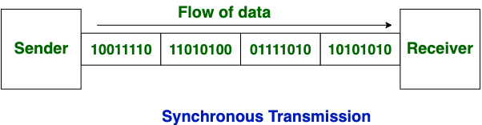

**Asynchronous Transmission:** In Asynchronous Transmission, data is sent in form of byte or character. This transmission is the half-duplex type transmission. In this transmission start bits and stop bits are added with data. It does not require synchronization.

**Example:**

* Email
* Forums
* Letters  
  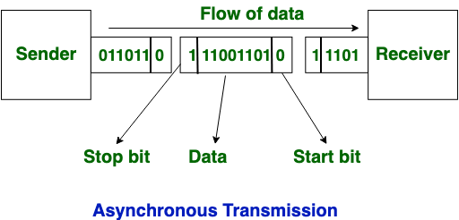

Now, let’s see the difference between [Synchronous Transmission](https://www.geeksforgeeks.org/synchronous-data-transfer-in-computer-organization/) and [Asynchronous Transmission](https://www.geeksforgeeks.org/asynchronous-serial-data-transfer/):

| **S. No.** | **Synchronous Transmission** | **Asynchronous Transmission** |
| --- | --- | --- |
| **1.** | In [Synchronous transmission](https://www.geeksforgeeks.org/synchronous-data-transfer-in-computer-organization/), data is sent in form of blocks or frames. | In [Asynchronous transmission](https://www.geeksforgeeks.org/asynchronous-serial-data-transfer/), data is sent in form of bytes or characters. |
| **2.** | Synchronous transmission is fast. | Asynchronous transmission is slow. |
| **3.** | Synchronous transmission is costly. | Asynchronous transmission is economical. |
| **4.** | In Synchronous transmission, the time interval of transmission is constant. | In Asynchronous transmission, the time interval of transmission is not constant, it is random. |
| **5.** | In this transmission, users have to wait till the transmission is complete before getting a response back from the server. | Here, users do not have to wait for the completion of transmission in order to get a response from the server. |
| **6.** | In Synchronous transmission, there is no gap present between data. | In Asynchronous transmission, there is a gap present between data. |
| **7.** | Efficient use of transmission lines is done in synchronous transmission. | While in Asynchronous transmission, the transmission line remains empty during a gap in character transmission. |
| **8.** | The start and stop bits are not used in transmitting data. | The start and stop bits are used in transmitting data that imposes extra overhead. |
| **9.** | Synchronous transmission needs precisely synchronized clocks for the information of new bytes. | Asynchronous transmission does not need synchronized clocks as parity bit is used in this transmission for information of new bytes. |
| **10.** | Errors are detected and corrected in real time. | Errors are detected and corrected when the data is received. |
| **11.** | Low latency due to real-time communication. | High latency due to processing time and waiting for data to become available. |
| **12.** | Examples: Telephonic conversations, Video conferencing, Online gaming. | Examples: Email, File transfer,Online forms. |